**DAILY ONLINE ACTIVITIES SUMMARY**

|  |  |  |  |  |  |  |  |  |
| --- | --- | --- | --- | --- | --- | --- | --- | --- |
| **Date:** | **22-5-2020** | | | | | **Name:** | **Likhitha.M** | |
| **Sem & Sec** | **6th sem ‘A’** | | | | | **USN:** | **4al17cs046** | |
| **Online Test Summary** | | | | | | | | |
| **Subject** | | **Operations research** | | | | | | |
| **Max. Marks** | | **30** | | **Score** | | | **30** | |
| **Certification Course Summary** | | | | | | | | |
| **Course** | **Python for machine learning** | | | | | | | |
| **Certificate Provider** | | | **Great learning** | | **Duration** | | | **1 week** |
| **Coding Challenges** | | | | | | | | |
| **Problem Statement:**  1.Write a C Program to implement various operations of Singly Linked List Stack.  2.write a simple applet java program to check whether the given number is armstrong number or not  3.Write a Java Program to separate the Individual Characters from a String | | | | | | | | |
| **Status:completed** | | | | | | | | |
| **Uploaded the report in Github** | | | | | **yes** | | | |
| **If yes Repository name** | | | | | **https://github.com/likhithaMantaral/Daily-status** | | | |
| **Uploaded the report in slack** | | | | | **yes** | | | |

Online Test Details:

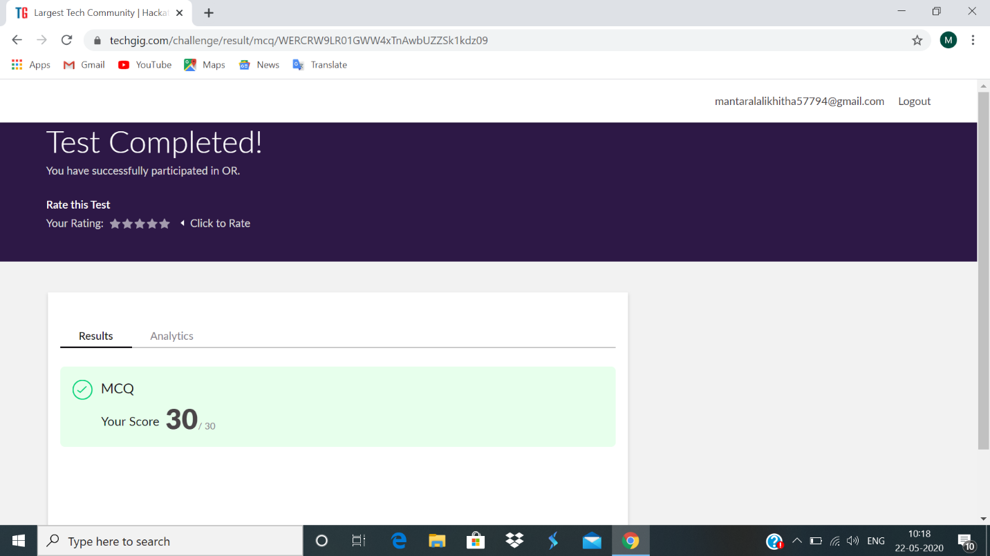

Certification Course Details:

**Conditional statements:**

Conditional statements in python are if, else and elif. For every condition or every logic we get an Boolean output, with that Boolean expression you can take a decision. For taking such decisions on the bases of some condition or logic we use elif logic, this statement can be used to perform individually as well. Solved many examples based on conditional statements.

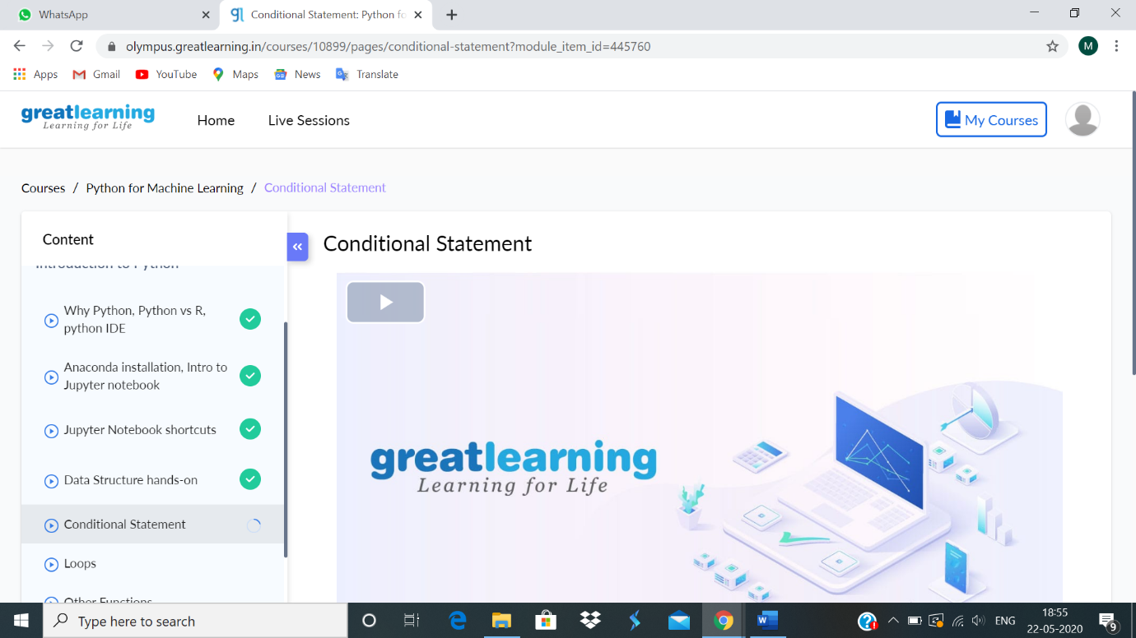

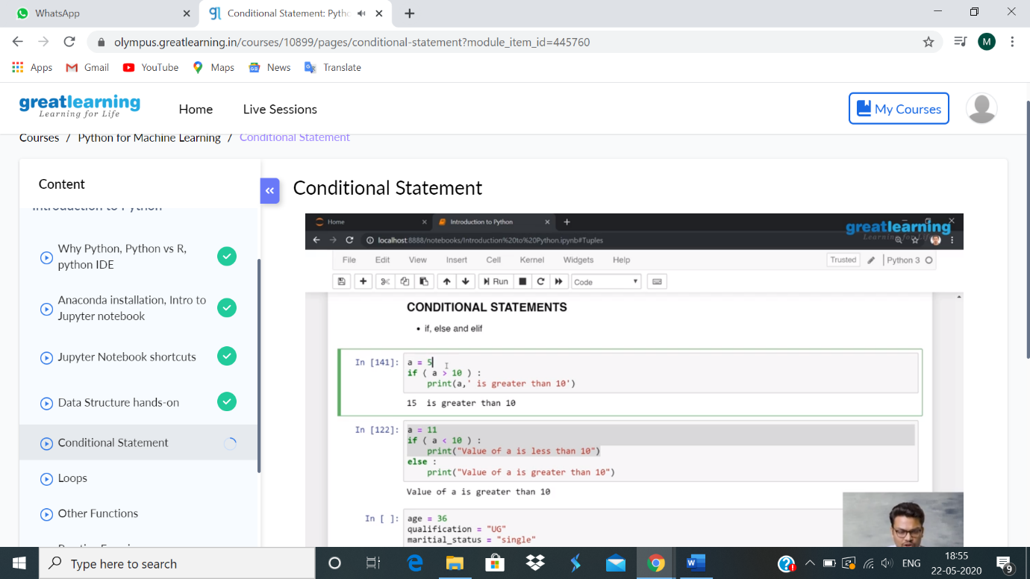

Coding Challenges Details:

1.

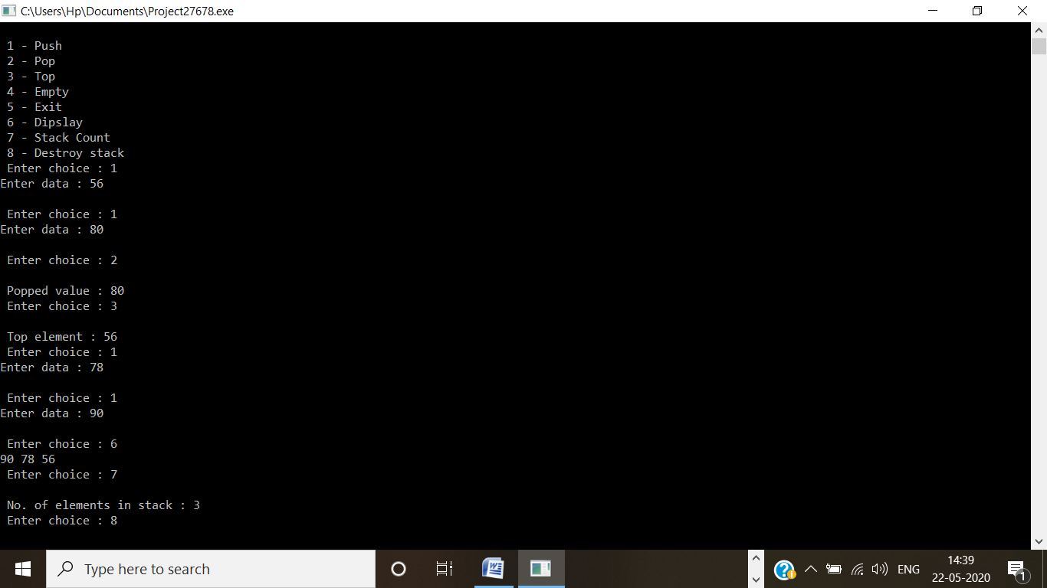

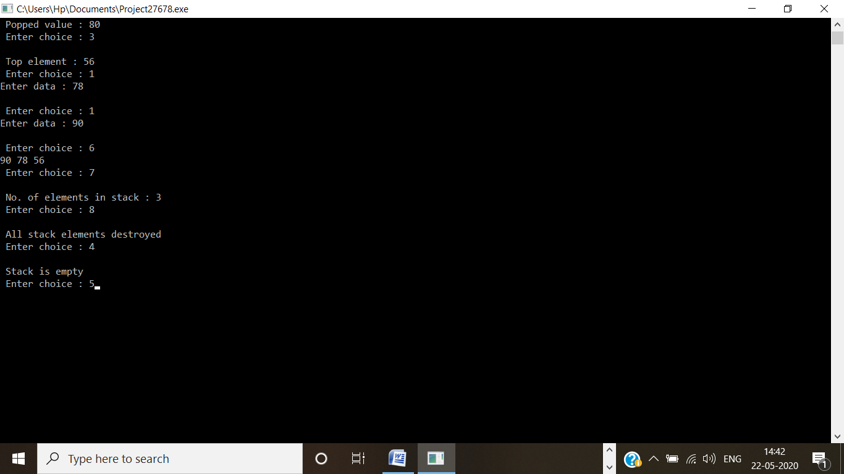

2.

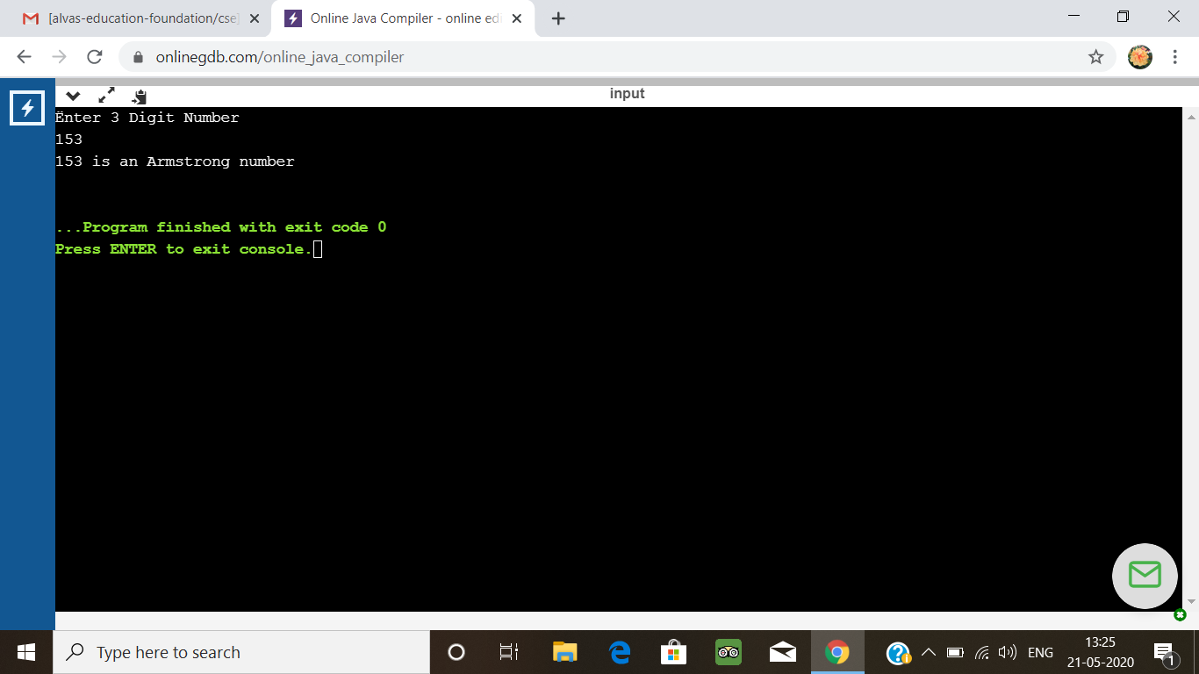

3.

